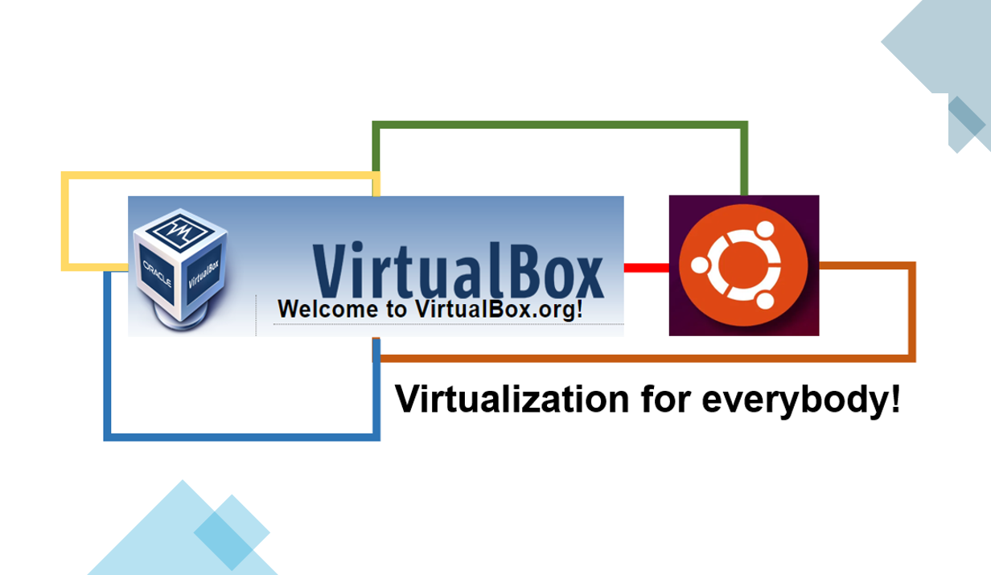

# **My “naive” virtualization & Linux installation tutorial**

## **Ola**

DevOps & Software Enthusiast|Engineer|

Virtualization for everybody!

Did you ever want to try using Linux in the safety of your windows desktop? There are actually more than a few ways to do that but let’s do this in the coolest possible way and learn together some basics about virtualization. Like in my previous “naive” tutorial(s), in this case, you also don't need any prior knowledge 😊 just open mind.

So, my assumption is that you never used some virtualization software and that you are using the Microsoft Windows environment for your work.

Just to go over some theoretical background and terminology that we will use as new “naive” virtualization experts! 😊

Virtualization allows your (e.g. Windows) operating system (let’s call it “host”) with all its installed software to run a new environment, on top of your existing operating system. This new environment is known as “virtual machine” and we will call it a "guest".

This “guest” virtual machine is created by the virtualization software by intercepting access to certain hardware components and certain features. Cool thing is that the “guest” operating system "thinks" it's running on a real machine.

Why use a virtual machine?

There are many reasons, but for personal use, it can be a great way to experience some new operating systems like Linux (e.g. Ubuntu, Fedora, Centos, Debian, OpenSUSE, Mint), try some programs in a safe environment, to develop and test software. For me, the main reason for the personal use of virtualization is fun to explore technology that I would probably not experience otherwise.

In order to do this, you will need some memory (6-8GB RAM is ok to start), some space on your hard disk (hopefully SSD & 16GB is fine) or even USB is ok. Generally, the better components of your “host” machine the better will be your virtualization experience.

Ready? Here we go!

**Step 1: Install Virtualization software (VirtualBox) and get Linux installation image**

There are a lot of options for Virtualization software (e.g. VMWare, Hyper-V) and VirtualBox will not be the first choice of all experts. I selected Oracle VirtualBox because it is free and easy to use. VirtualBox is a real multiplatform jewel and can run on host operating systems including Windows, Linux 2.4 and onwards, Server 2003, Solaris, OpenSolaris, and OpenBSD, and can also install these as guest operating systems.

### **a) download Oracle VM VirtualBox software**

* got to:

<https://download.virtualbox.org/virtualbox/6.1.4/VirtualBox-6.1.4-136177-Win.exe>

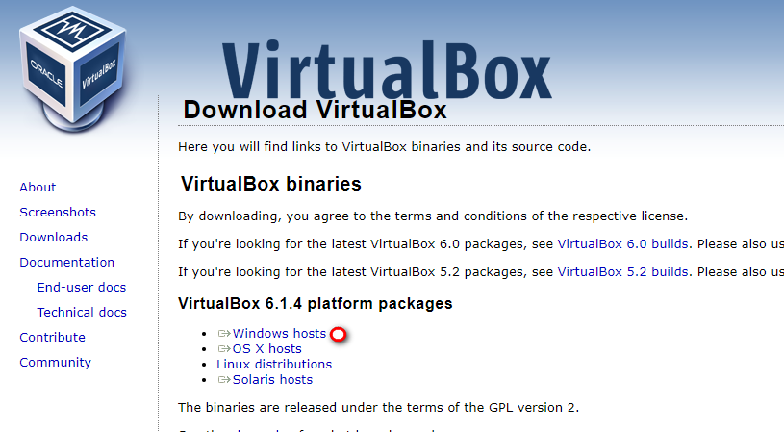

### **b) install VirtualBox software**

* run the installer and use all defaults settings

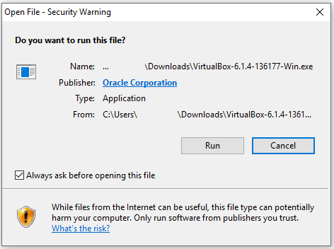

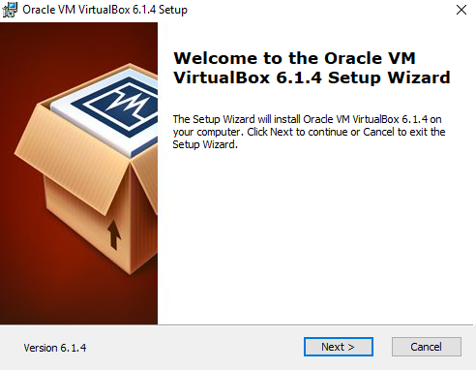

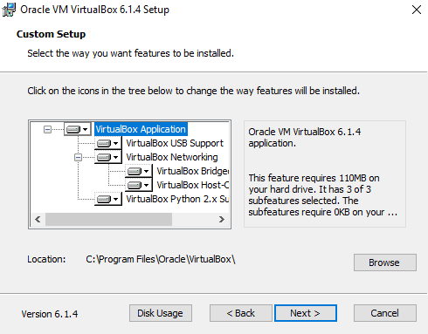

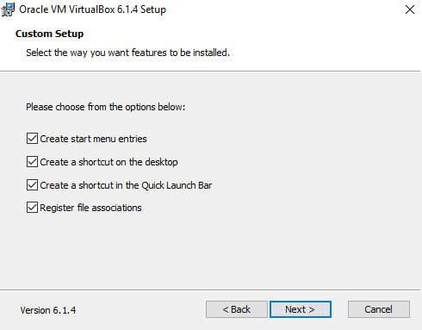

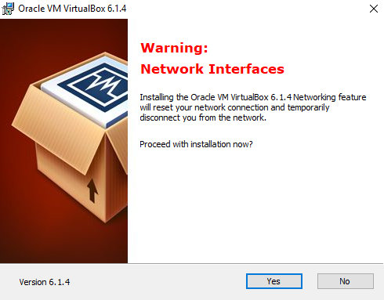

### **c) download Linux .iso installation image (Ubuntu)**

There are a lot of Linux distributions but two main commercial distributions popular with regular users:

* Debian / Ubuntu-based (e.g. Linux Mint, Kubuntu, Lubuntu, Ubuntu MATE, …)
* RPM-based (e.g. Red Hat Linux, CentOS, Fedora, openSUSE, …)

So many Linux derivate are out there! You can check the Wiki page to have some idea: <https://en.wikipedia.org/wiki/List_of_Linux_distributions>.

The abundance of Linux distribution is a blessing and the curse at the same time. First-time users are reluctant about which one to try and also there are some “clans” in expert Linux community. My opinion that you will probably do fine with any well-known Linux operating system.

My personal choice is CentOS, but in this case, I will choose Ubuntu just to make peace between Debian and Red Hat warring factions. BTW, why to fight, you can just hate Windows together. 😊

* go to Ubuntu download page and get your .iso image:

<https://ubuntu.com/download/desktop/thank-you?version=18.04.4&architecture=amd64>

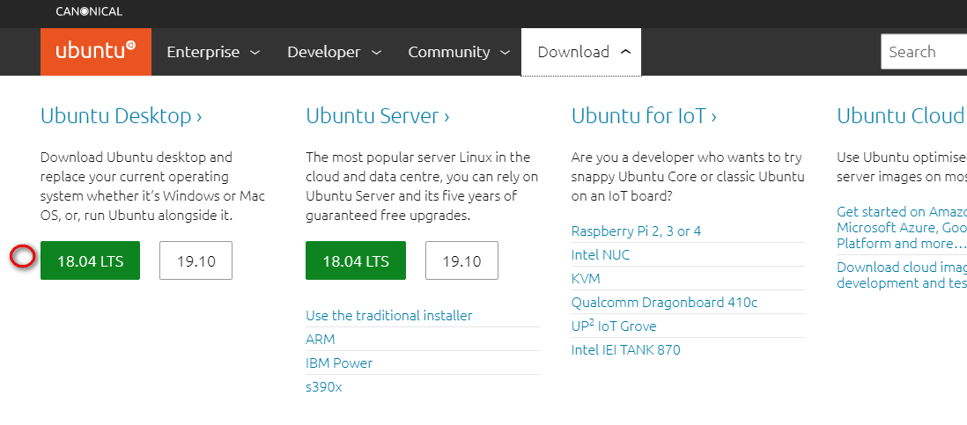

* the download will start and you will soon get your free Linux that will be your “guest” operating system (e.g. ubuntu-18.04.4-desktop-amd64.iso)

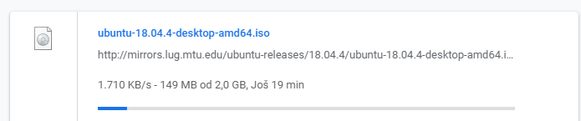

## **Step 2: Create a Linux guest virtual machine with Virtualization software (VirtualBox)**

* start your VirtualBox with desktop icon

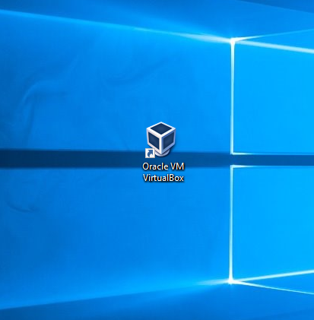

* the application will open, and you can see a new portal to the virtualization world!

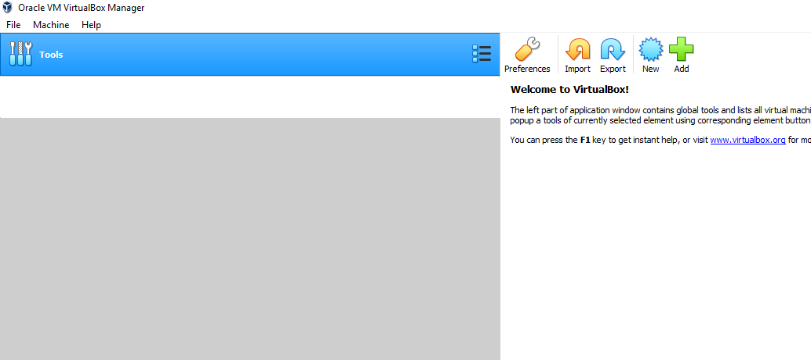

* select the “New” icon:

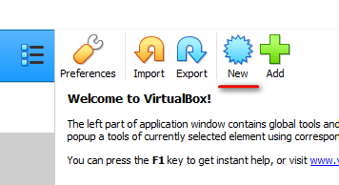

* in the “Create Virtual Machine” dialog provide the name for your virtual machine (e.g. “MyUbuntu”), select Type “Linux”, select Version “Ubuntu (64-bit)” and click “Next”

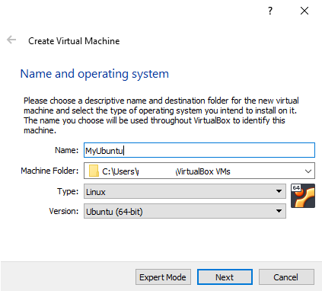

* on “Memory size” dialog allocate 2048 MB for a better experience (or you can go with recommended memory size if you have less RAM then 8GB) and click “Next”

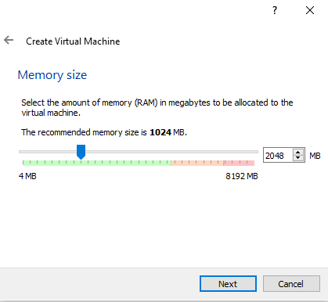

* on “Hard disk” dialog use default option “Create a virtual hard disk now” and click “Create”

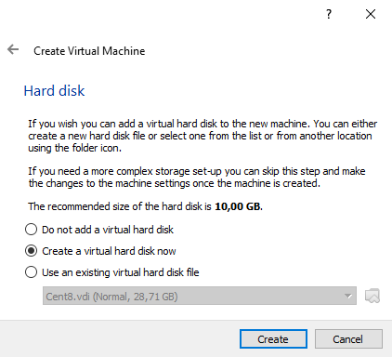

* on “Hard disk file type” use default option “VDI (VirtualBox Disk Image)” and click “Next”

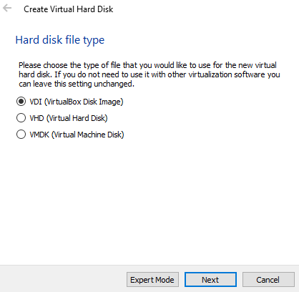

* on “Storage on physical hard disk” use default option “Dynamically allocated” and click “Next”

Note: this option will limit the initial size of the virtual machine on your “host” until it is needed. However, the “Fixed size” option could be a better option for performance in some cases, but not significantly in our scenario.

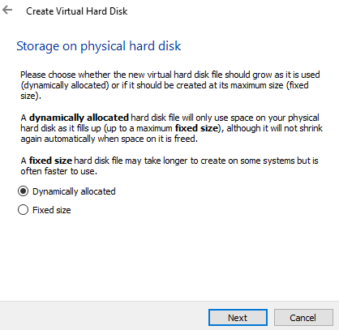

* on “File location and size” allocate 16GB (default 10GB is also fine) and click “Create”

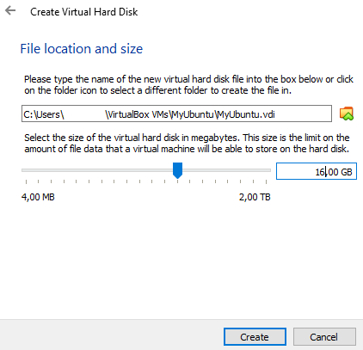

Your virtual machine is created and ready for the installation of our Linux operating system.

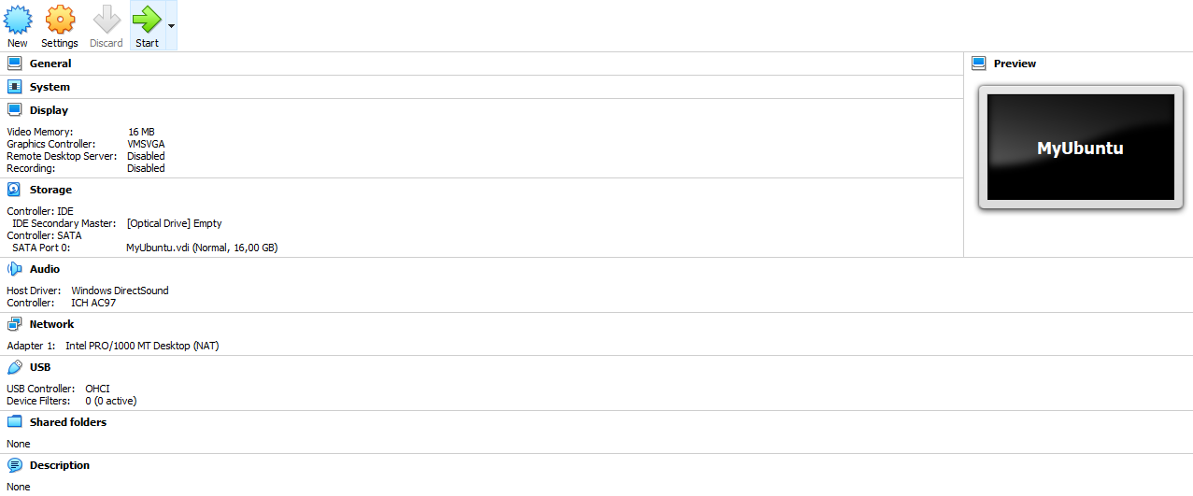

## **Step 3: Install a virtual machine with a guest Linux operating system (Ubuntu)**

* click on “Storage” on your virtual machine settings page on the right

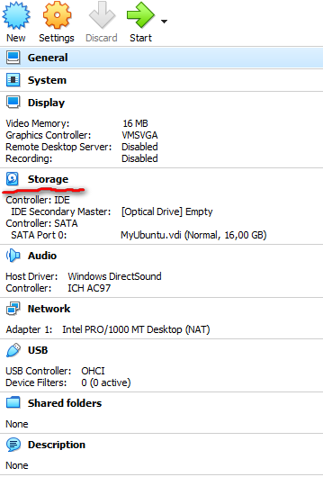

* click on Optical Drive icon under “Controller: IDE” and on the right side select “Choose Virtual Optical Disk File” option

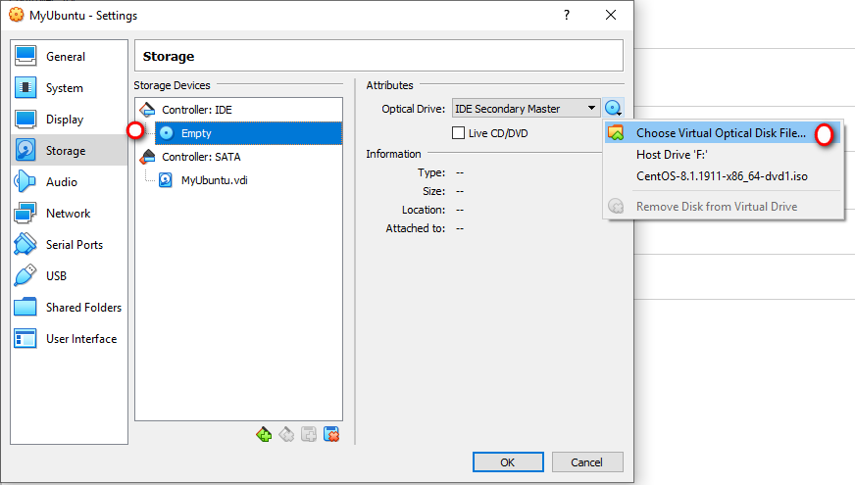

* select the Ubuntu .iso file that we downloaded in Step 1 (e.g. ubuntu-18.04.4-desktop-amd64.iso) and click “Open”

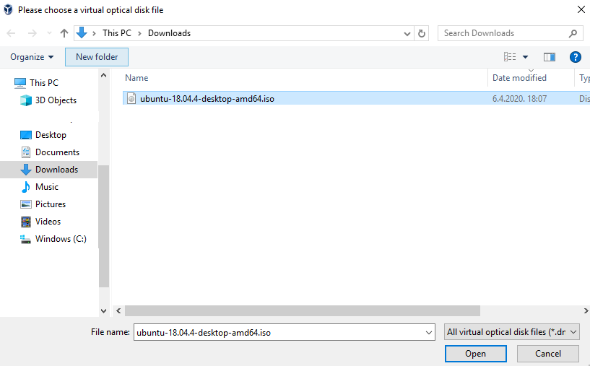

* now the “ubuntu-18.04.4-desktop-amd64.iso” image is added to the “Controller: IDE”; click OK to close the virtual machine "Settings" dialog

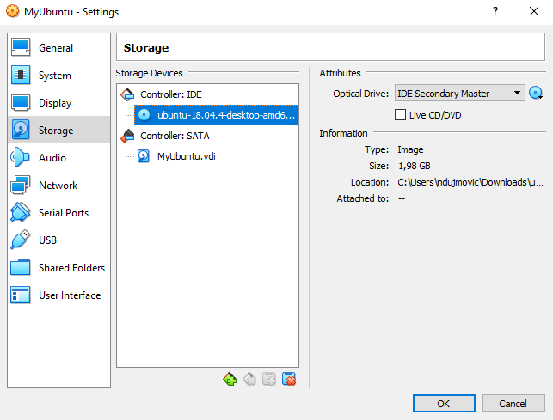

* let’s start our virtual machine to begin the installation of the operating system by clicking “Start” green arrow

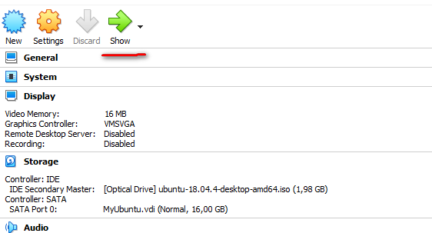

* a new window with a virtual machine will be open as Ubuntu starts via live CD mode

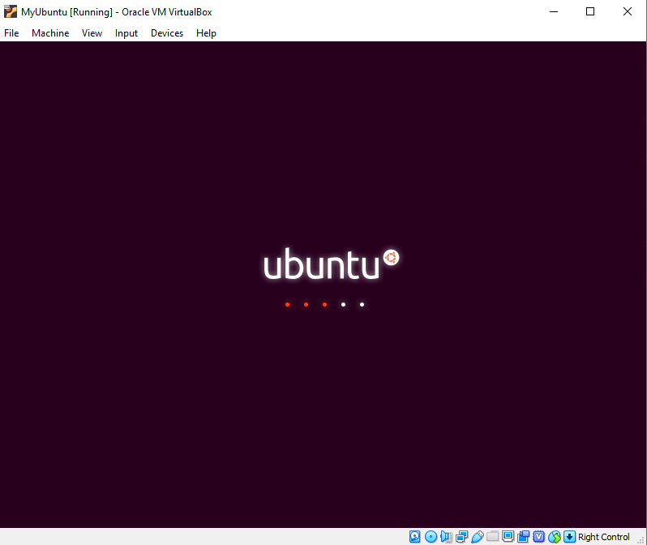

* soon the Welcome screen will appear; please choose “Install Ubuntu” (if you like you can choose a different language or change it later)

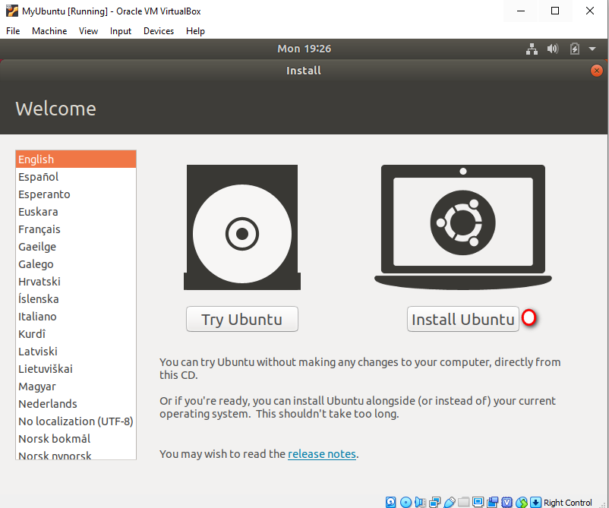

* select your keyboard layout

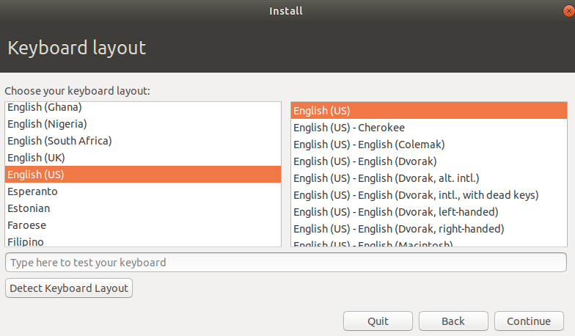

* just choose “Normal installation” on “Updates and other software” screen

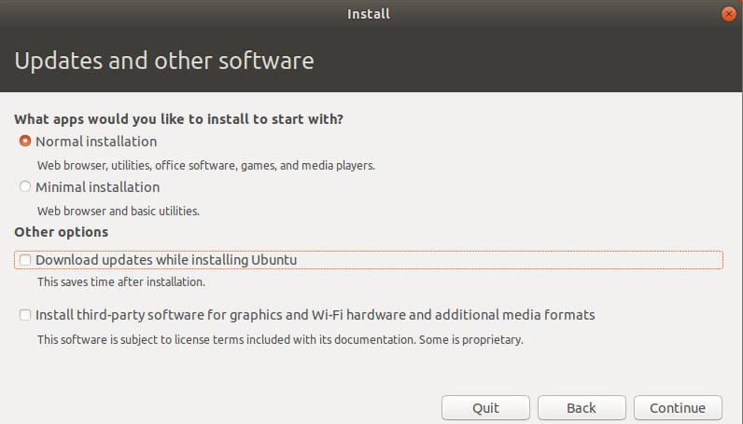

* on “Installation type” screen choose “Erase disk and install Ubuntu” option

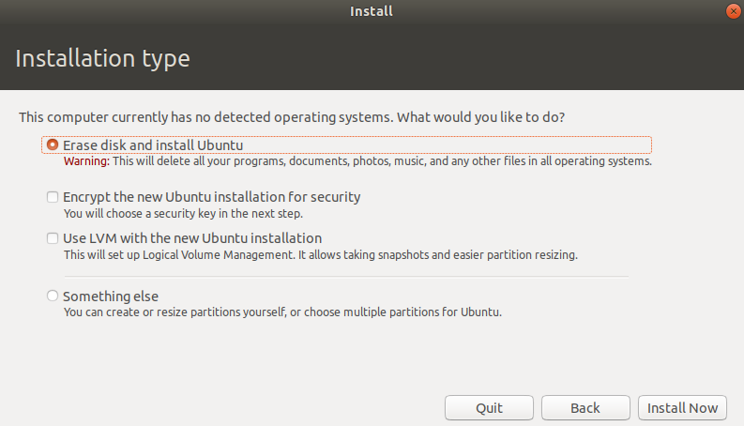

* confirm your choice on the dialog that will pop up with the “Continue” button

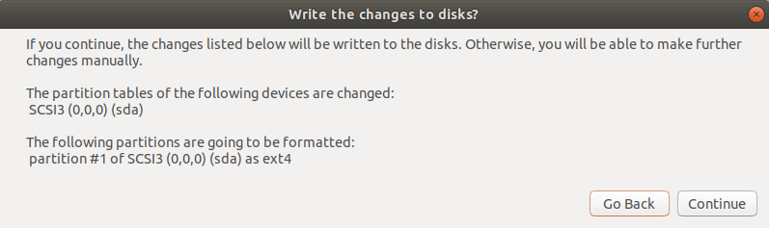

* select your time-zone

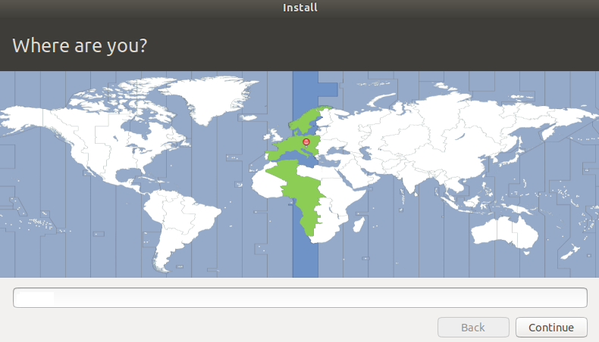

* provide your user name, password and click “Continue”

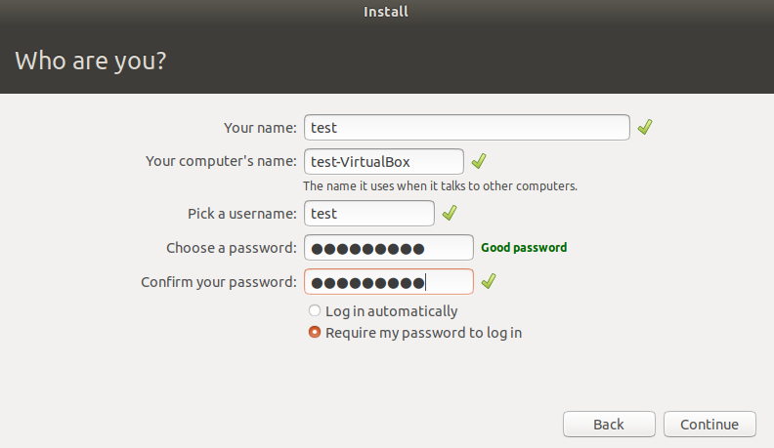

* the installation will continue and you will see the progress below

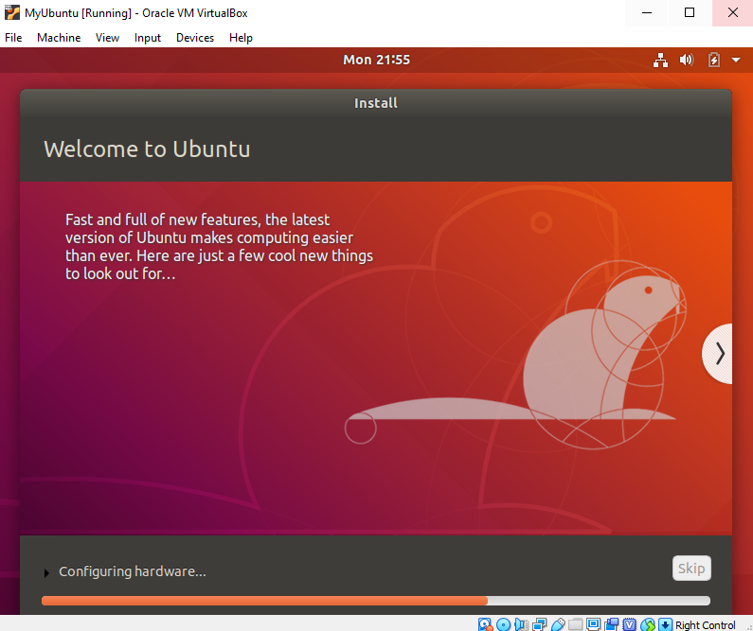

Very soon, the full-featured Linux operation system is ready to be used!

* the system will ask for the restart but let us first remove the installation image from the virtual optical drive by going to the VirtualBox menu: “Devices” -> “Optical Drives” and uncheck .iso image.

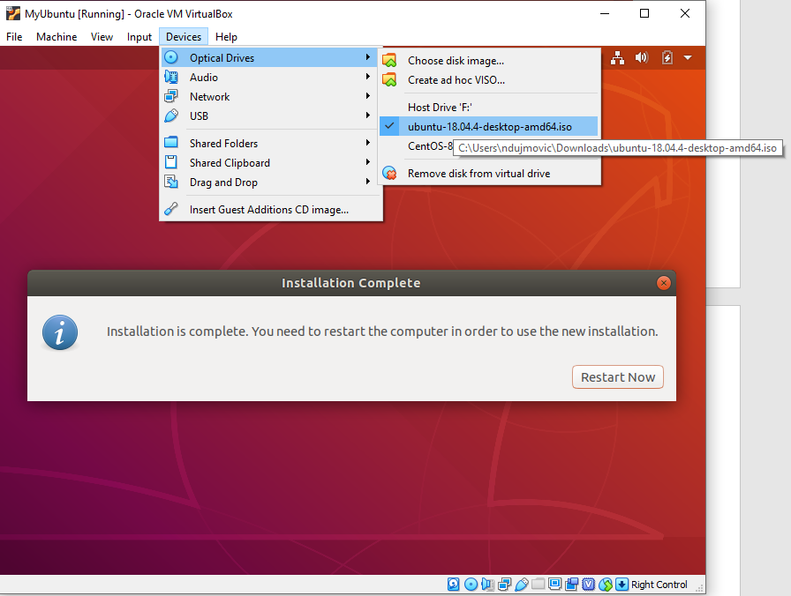

* on popup dialog confirm “Force Unmount”

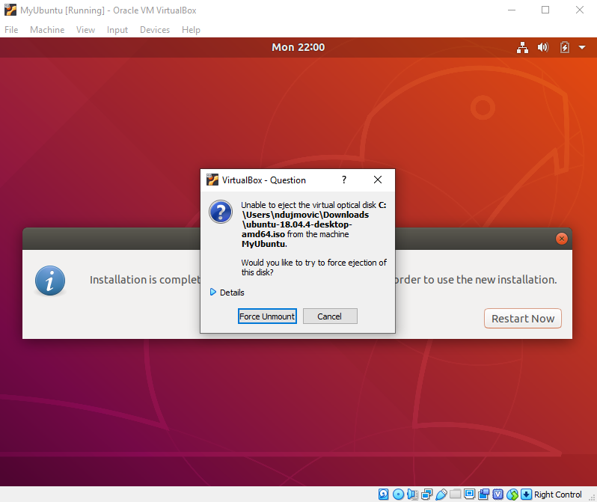

* in case of the black screen go to VirtualBox menu "File” -> "Close”

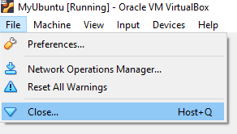

* choose “Power off the machine” option to close the machine

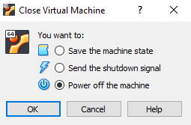

Now you can restart your virtual machine to do some fine-tuning!

## **Step 4: Post-installation actions**

* the virtual machine is now restarted or started again by clicking:

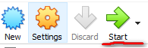

* a new window will open, and your guest Linux virtual machine will be stared on top of your existing operating system

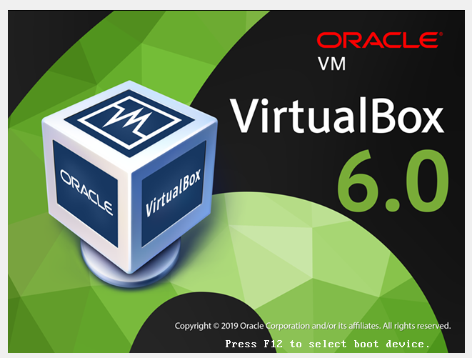

* click on your user and enter the password to sign in to your Ubuntu

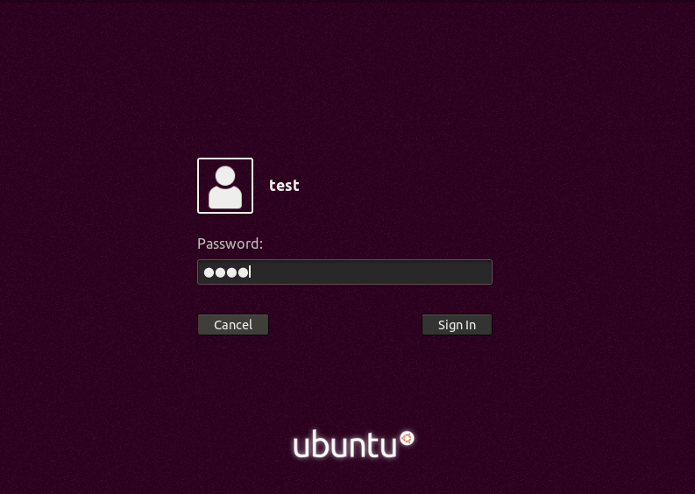

Great! The virtual (or guest) machine is ready to be used!

* click the green button with “Next” on the top right corner and then “Done” to close welcome Ubuntu messages

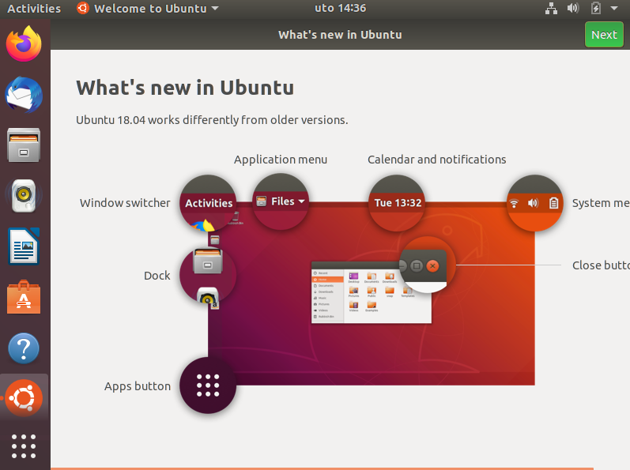

* you can also install updates if “Software Updater” dialog pops up

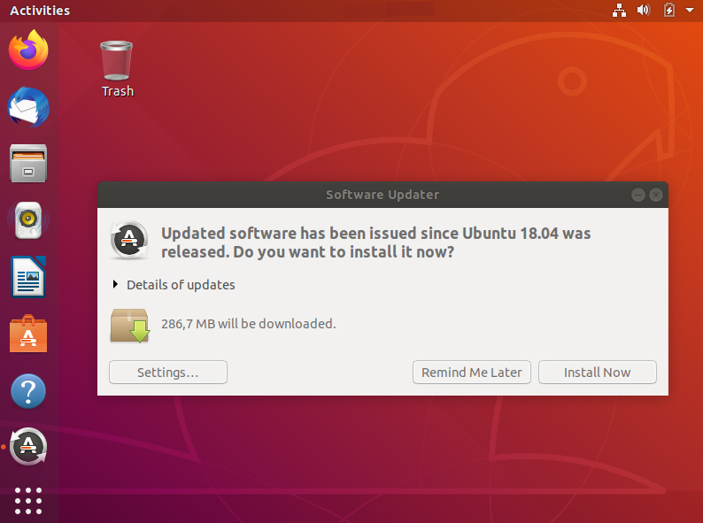

* this action will require authentication and you should provide the password in “Authentication Required” dialog

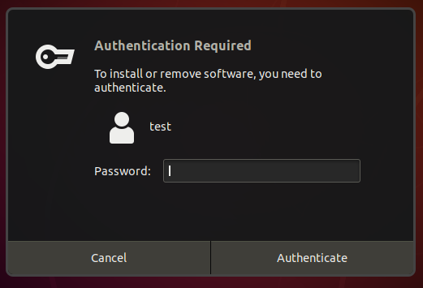

* this will trigger the installation of updates and you can follow the progress

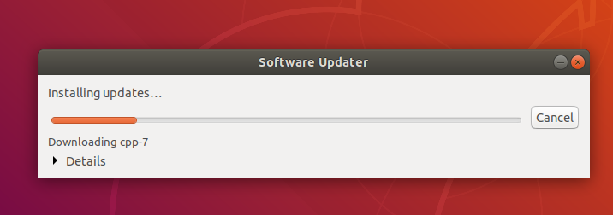

* when the installation of updates is finished restart the system (this is something that Ubuntu will ensure regularly for you 😊)

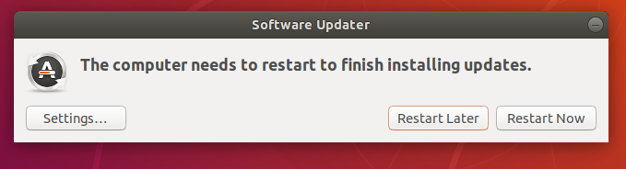

Restart is finished and we are back to our Linux guest Ubuntu system! Just repeat sign in and you are back to the desktop.

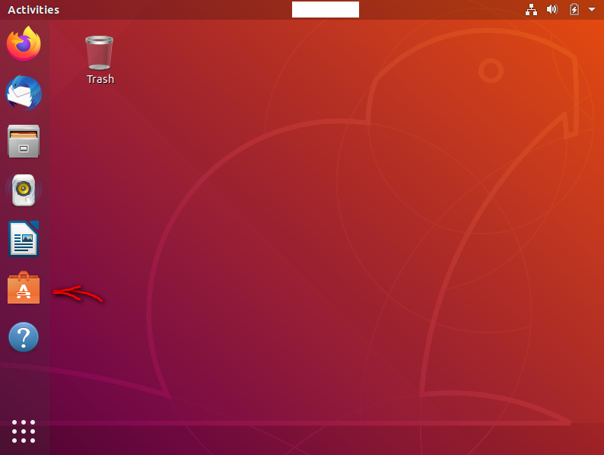

Now is time to explore your Ubuntu and see how the interface is designed. It is a new experience that will take some time and I will leave it totally to you. Most of the things are intuitive and you will recognize programs and functionality of icons. Maybe a good place to start is “Ubuntu Software” that I marked with the arrow above. If you see Linux desktop for the first time you will be positively surprised with the rich offer of free software and even some cool games.

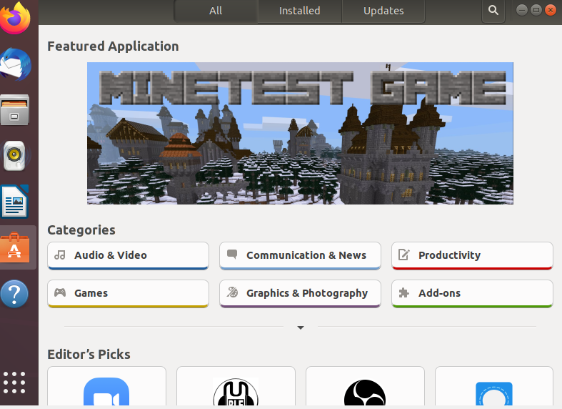

Ok, everything is not perfect yet. You will notice that the virtual machine window is rather small, and resolution cannot be adjusted even if you try “Full-screen Mode” from the VirtualBox menu.

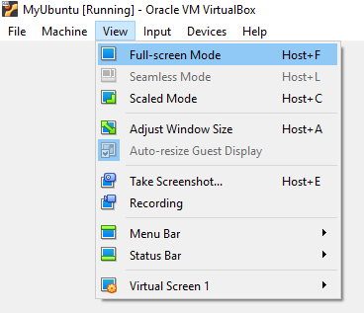

The reason for that is that virtual hardware is not tuned for Ubuntu. However, this can be easily resolved 😊. Your favorite visualization software, VirtualBox, has ensured that you have the best visualization experience!

* click at the bottom left corner of the screen on “Show Application” icon

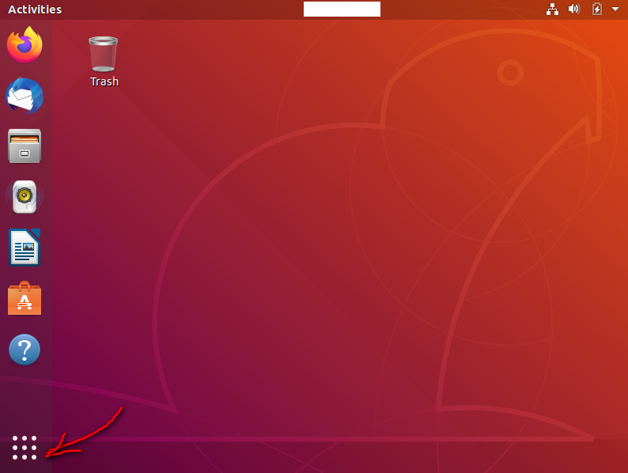

* write terminal on the search box and click on the “Terminal” icon that will appear

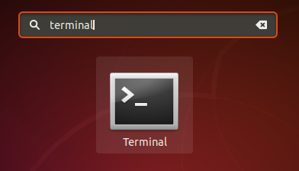

The terminal window will help us with further installation steps.

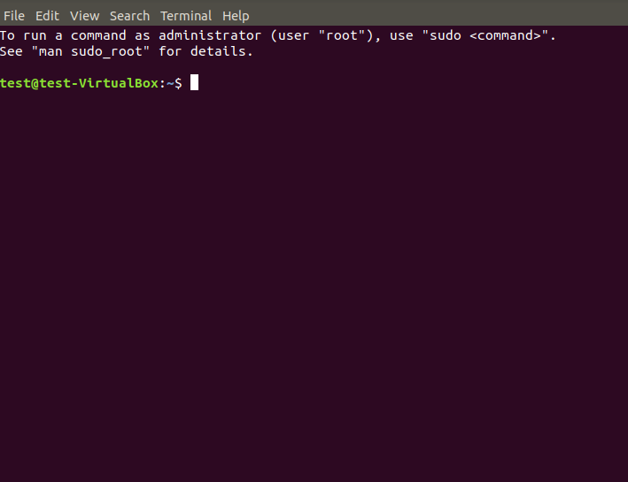

* let’s update our Ubuntu guest operating system software packages by running following commands in the terminal:

sudo apt update

sudo apt upgrade

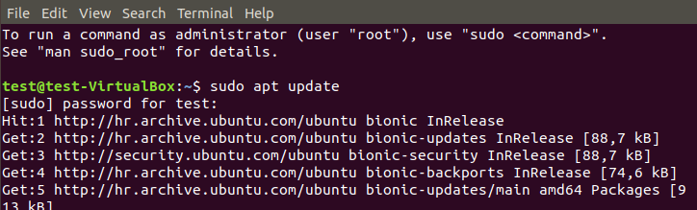

* write “y” to confirm upgrade when asked and press enter

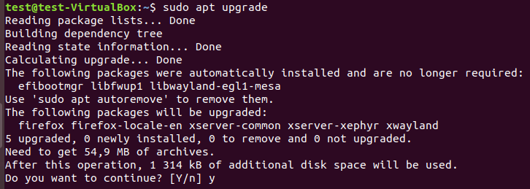

Once the upgrade is completed, reboot your system to load the recent upgrades.

* click on top right corner at little down arrow and press “Power Off” button marked with the red arrow below

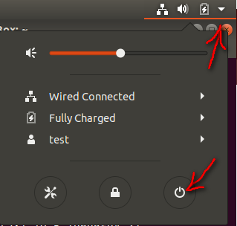

* on “Power Off” dialog select “Restart” button and after systems restarts sign in again

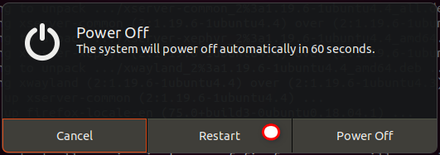

* open again the “Terminal” via “Show Applications” icon and search



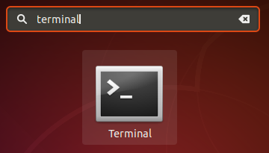

* install required packages as follows:

sudo apt install build-essential dkms linux-headers-$(uname -r)

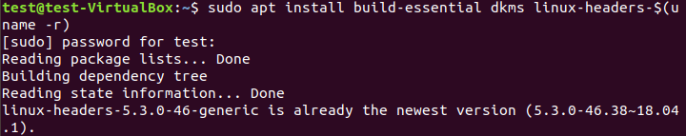

* write “y” to confirm upgrade when asked and press enter

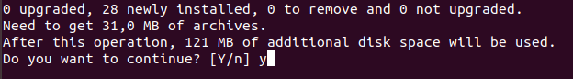

* close the “Terminal” window and go to the VirtualBox menu to select “Devices” -> ”Insert Guest Additions CD image…”

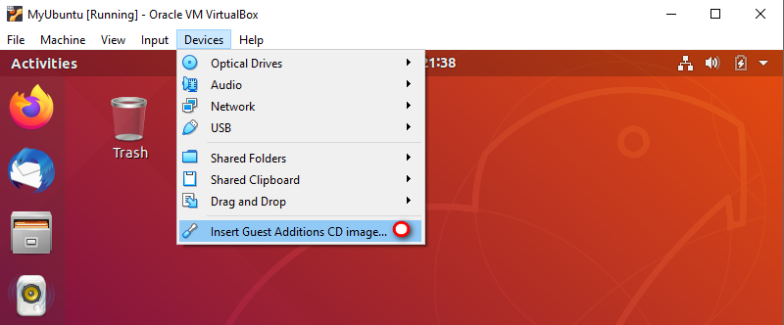

* you will see that the VirtualBox guest additions CD image is mounted on your desktop and the dialog window with “Run” installation will pop up

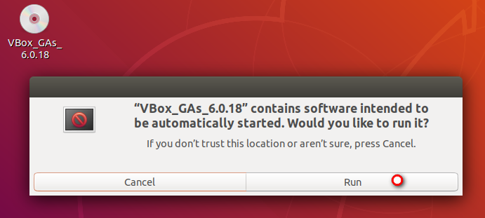

* run the installer and confirm it by providing a password

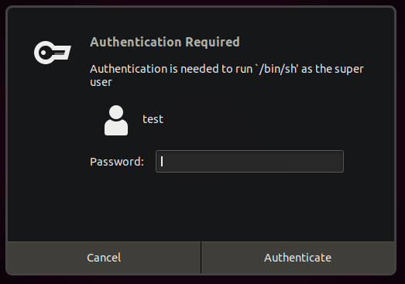

* the “Terminal” window will open, and you will see the installation progress

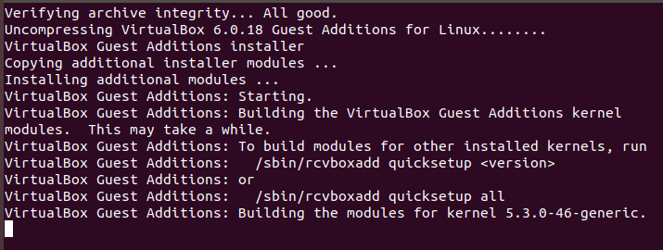

* press enter to close the “Terminal” window

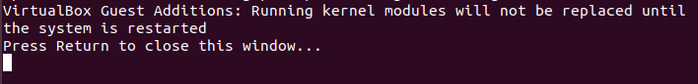

* unmount the VirtualBox guest additions CD image by right-clicking on its desktop icon and select “Eject“

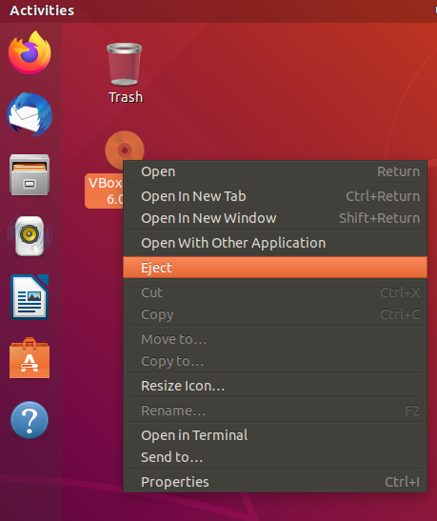

* and then restart the virtual machine as you learn previously

When you sign in again you will have Ubuntu guest Linux virtual machine in full resolution.

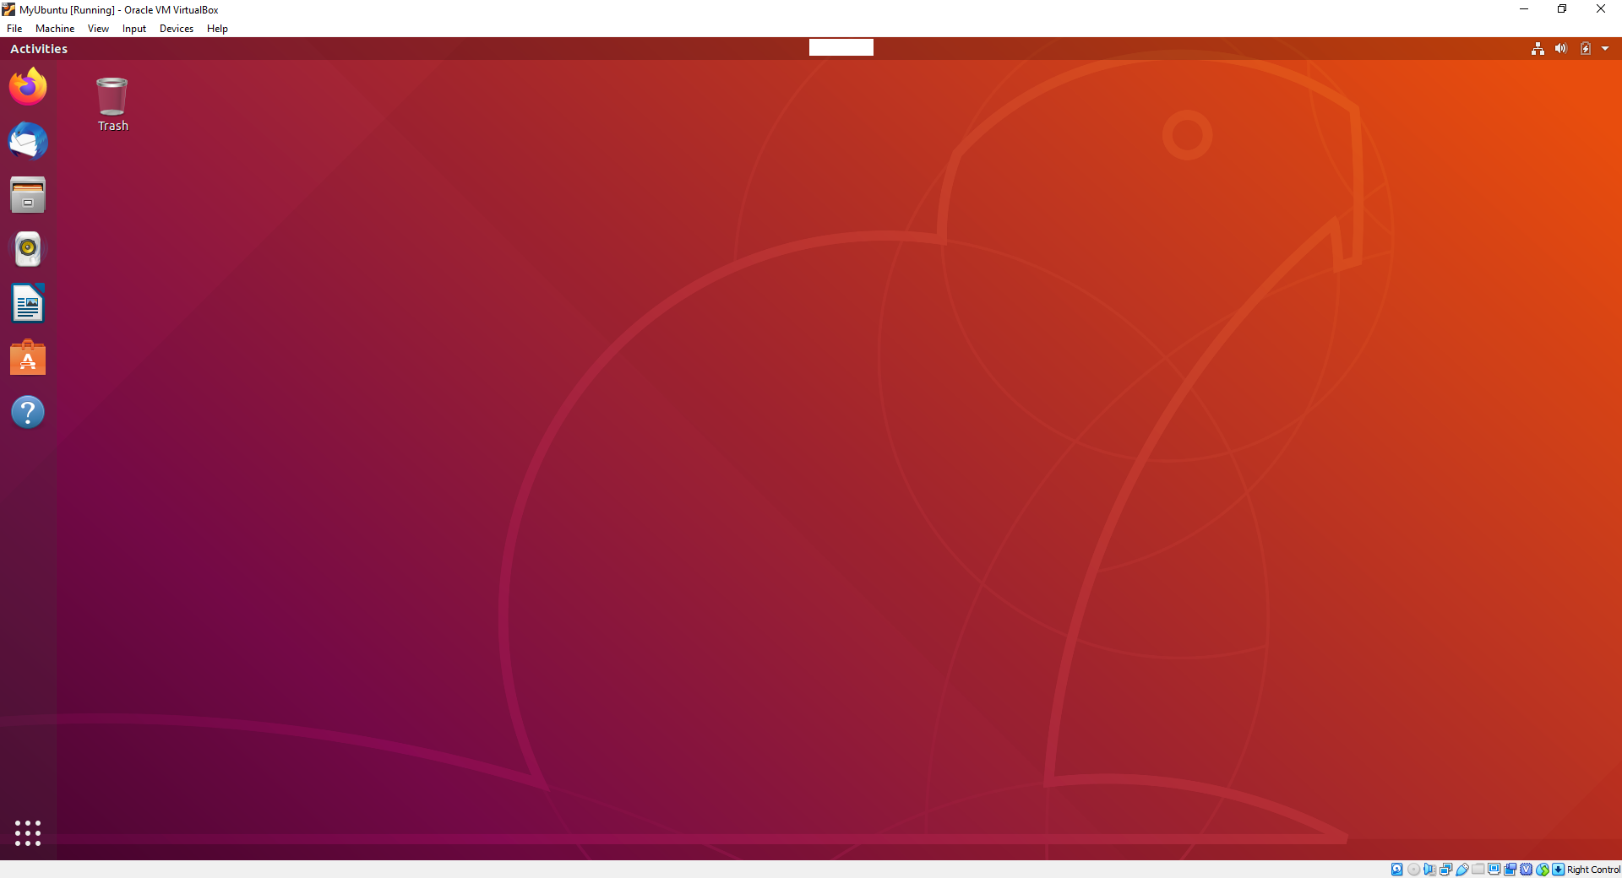

* try also “Full-screen Mode” in VirtualBox “View” menu item to have a full Ubuntu desktop experience

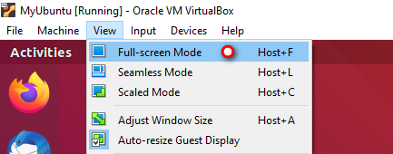

For a moment you will forget that you are a Windows user as you will be lost in investigating your brand-new operating system. 😊

* to get back to guest window mode just move the mouse cursor on middle button area of the screen and click little window icon (or press “right Ctrl+F” keyboard shortcut)

No alt text provided for this image

Try running an Internet browser!

Mozilla Firefox is pre-installed as a true open-source representative, but you can also choose to install another browser via the “Ubuntu Software” application.

* click on “Firefox” icon on the left and you will see that you are connected and ready to go anywhere

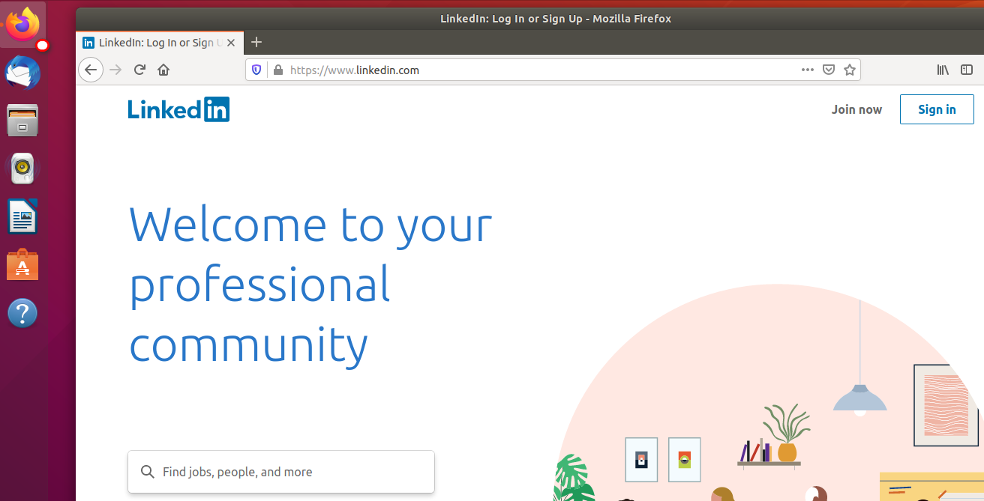

One more important and super cool feature of the virtualization universe is integration features with a host system (Windows in your case).

At a certain point in time while using the guest operating system you will wonder how to easily share files between host and guest and vice versa. Of course, you can share files over internet services but let’s assume that you want a safe way to do it without need to go online.

VirtualBox has just what you need!

On VirtualBox menu select “Devices” -> “Shared Folders” -> “Shared Folders Settings…”

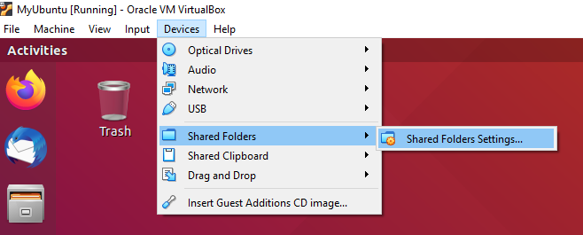

* on “Shared Folders” dialog that will pop up click on “Add new shared folder” icon

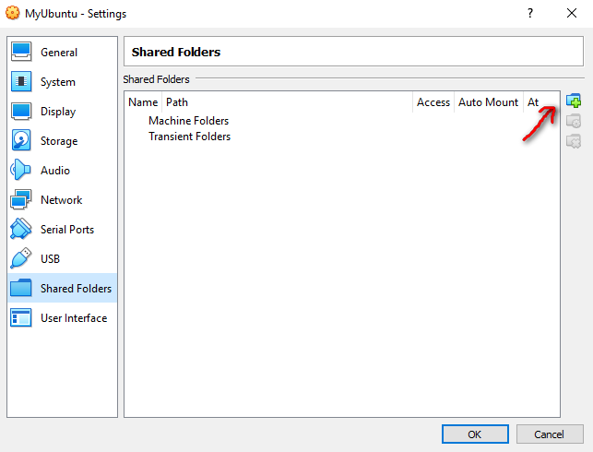

* on “Add Share” dialog select host folder that you want to share with Ubuntu guest and check “Auto-mount” and “Make Permanent” checkbox

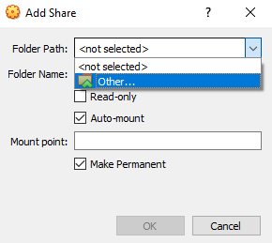

* selected shared folder will be displayed on the list after you click “OK”

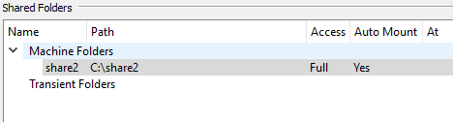

* click “OK” again on “Shared Folders” dialog to save changes

You will see that the shared folder icon “sf_share2” is mounted on your Ubuntu desktop.

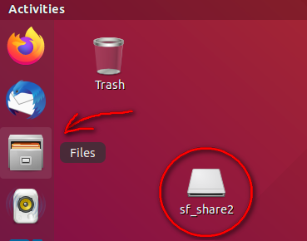

* if you start “Files” application (pointed on the picture above), you will see also “sf_share2” shared folder mounted on your directory listing

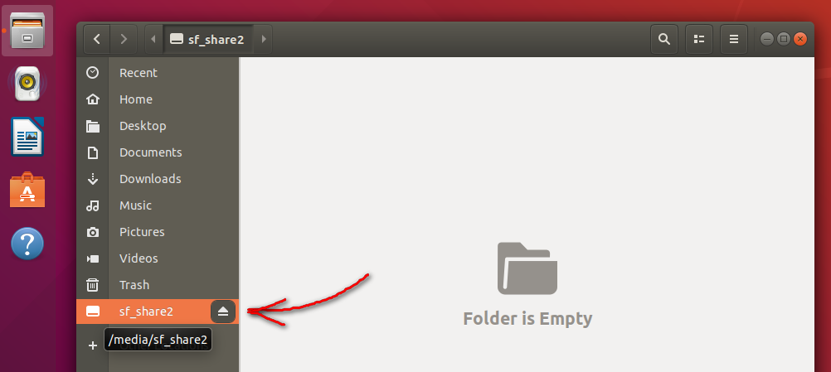

* however, it not accessible to your current user due to provisions problem (Ubuntu is always careful about security!)

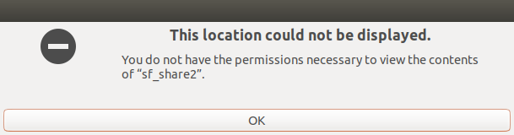

* close the “Files” application and open again the “Terminal” via “Show Applications” icon and search

No alt text provided for this image

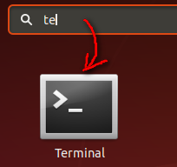

Now we will do some configuration in Linux and this could look a little bit scary to standard windows user. But there is no need for that. Just be free to explore Linux world and if something goes wrong this is a virtual machine after all. You can always make another one! 😊

To set VirtualBox shared folder permissions we have to edit the “group” configuration file. Here we will have to add your username (in my case user is “test”) to VirtualBox shared folder group “vboxsf”.

* write following command in and configuration file “group”:

sudo gedit /etc/group

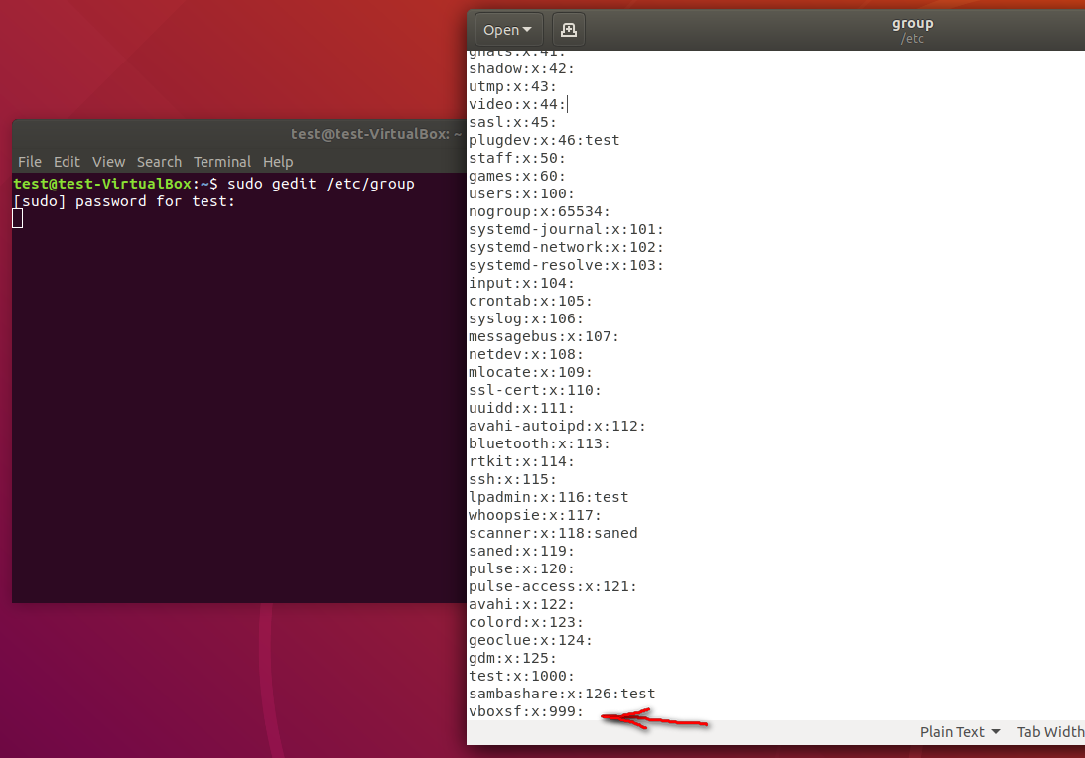

* look for the line “vboxsf:x:999:” (the number varies) and add at the end: yourusername

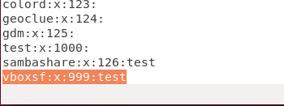

In my case with user “test” the line will look like this:

vboxsf:x:999:test

* save the file in the text editor, close it and then also close the “Terminal”

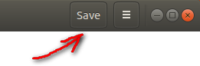

* to take effect you should log out and then log in, or simply restart the system

When the Ubuntu desktop is back again open the “Files” application and you be able to access the host machine shared folder. Wow!

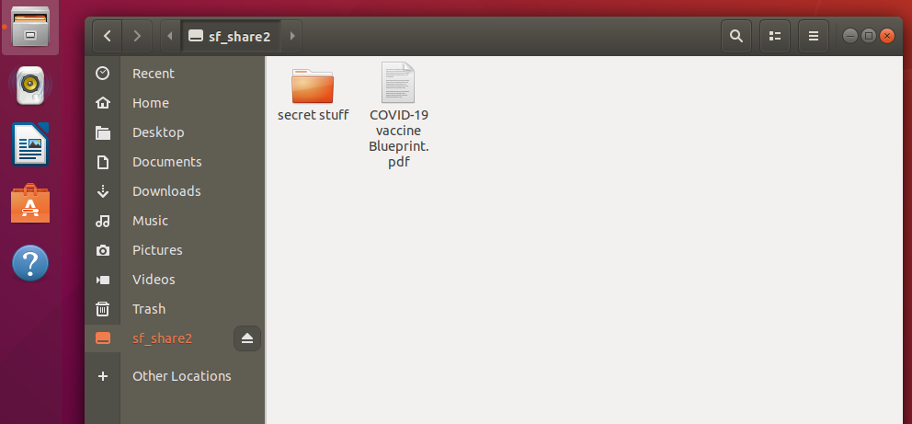

Also, you can access the shared folder by double-clicking desktop shared folder icon “sf_share2”.

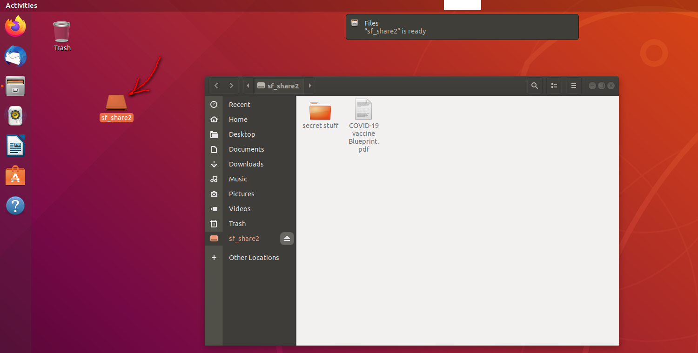

Additionally, you should also provide integration between guest and host machine by enabling “copy & paste” functionally. Fortunately, this is a fast thing to do!

* in VirtualBox menu select “Devices” -> “Shared Clipboard” and choose a mode (Bidirectional is most useful for me)

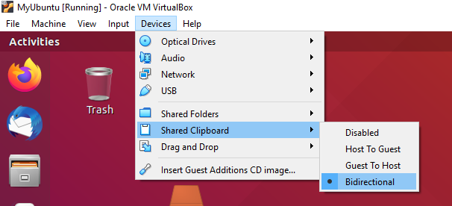

Your whole virtual machine (configuration, disk, etc.) is saved on your hard disk, and it is easy to copy it on another location or USB drive. You can use this copy as a fully working virtual machine on some other computer.

· in order to do that just copy "MyUbuntu" folder at your “host” Windows location

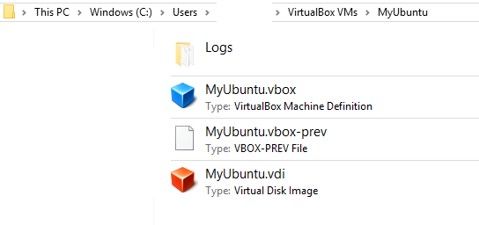

## **Congratulation!**

You now know how to use virtualization and only the sky is a limit for your next project.